2.5 The Precise Definition of a Limit

The definition of a limit presented in section 2.2 is vague…too vague. What do the following phrases mean?:
“x is close to 1” “make the values of arbitrarily close to L”

We wish to add some rigor and exactitude to these types of statements.

General Idea:
How could we show that ?

We want to show that we can make y-values of the function as close to 5 as we would like as long as we pick x-values close enough to 3. We will use the following picture to outline this idea.

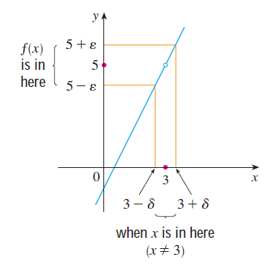
Notice that in the picture at the right we measure closeness using two different Greek letters:

- (delta) is used to measure the distance from 3 (x direction)
- (epsilon) is used to measure the distance from the limit value 5 (y direction)

Notice that when an x-value is within the interval resulting y-value will be within the interval . We can use this picture to help us understand the following rigorous definition of limit.

We now develop the following rigorous definition.

Definition: Let be a function defined on some open interval that contains the number a, except possibly a itself. Then we say that the limit of f(x) as x approaches a is L, and we write when the following holds:

For every number there is a number such that if x is in the interval , then will be in the interval .

Note: Determine the interval communicated by each of the following absolute value inequalities.

Using this knowledge we could rewrite the intervals in the previous definition in the following way.

Definition: Let be a function defined on some open interval that contains the number a, except possibly a itself. Then we say that the limit of f(x) as x approaches a is L, and we write when the following holds:

For every number there is a number such that if , then .

Note: Writing our intervals using absolute value inequalities will actually make it easier to verify the value of a limit.

Example 1: Consider the motivating example where we looked at . Suppose that someone challenged you to show that the y-values of the function can get with 2 units from 5. Determine a value of that would make this possible.

In this example we can see that we have , , , and . We want to determine a value of such that if then . That is to say, if , then .

We will start by investigating the behavior of the y-values by looking at the interval .
We see that
.
So, if then we could say that
and therefore .

Therefore we need. We have showed that if we pick an x-value in (meaning x is in ) then (meaning is in ).

Example 2: Prove that using only the definition of limit.

When we do a problem like this, we always begin by doing scratch work to find our delta. Then, we write our solution after we have a delta in mind. For a general proof we need to work with an arbitrary epsilon, that is, we assume epsilon is some positive number that we do not know.

Scratch work:
We want to pick a delta such that: “if , then ”. So, we have that . We note that:

Notice that if we take , then , and we will have that the if-then statement holds.

Note: Our delta will usually depend on epsilon. Notice that the formula we obtained for delta agrees with the most recent examples.

Solution:
Suppose is some positive real number. Let , and suppose that . Then,
Therefore we can say that .

Example 3: Prove that using only the definition of limit.

Scratch work:
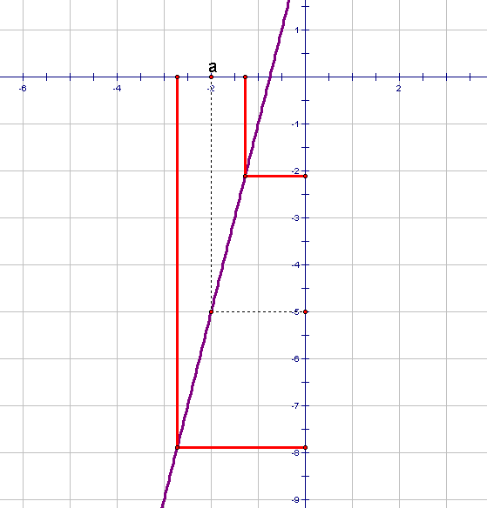
We want to pick a delta such that: “if , then ”. So, we have that . We note that:

Notice that if we take , then , and we will have that the if-then statement holds.

Solution:
Suppose is some positive real number. Let , and suppose that . Then,
Therefore we can say that .

Note: See section 2.5 of the textbook for more examples of an epsilon-delta proofs.
Note: There are similar rigorous epsilon delta definitions for one sided limits. We now present the rigorous definition of an infinite limit (we present , is similar).

Definition: Let be a function defined on some open interval that contains the number a, except possibly a itself. Then, we write when the following holds:

For every number there is a number such that if , then .

Note: If time permits, the instructor will explore the example of and show how it intuitively relates to the definition above.

Note: We can easily adjust the definition of above to define by requiring that .

